Assignment 2- Case Study (8995-G level Task)

Stage 5 Lab Activities

Refactoring SmartCare into a Layered Architecture
HUMAN ANALYSIS -> REFACTOR -> AI REVIEW -> VERIFY | 1 hour

A - Inspect SmartCare v0.4
Identify domain, workflow, data-access and presentation responsibilities currently mixed together.
Domain is handled by the classes Patient, Practitioner and Appointment (They are called the Domain Classes for a reason)
Workflow is done through main specifically the book and cancel paths.
Data access is done though a list in main (appointments = []) and a list in practitioner that holds the same data.
Presentation is done through the main loop with input and print.

B - Propose Architecture
Draw Presentation -> Service -> Domain, with Service using a Repository abstraction and Persistence implementing it.

Presentation

Service

Repository contact

Persistance

Domain
uses
Implements

Stores
Depends on
Depends on

C - Create Package Structure
Create domain/, services/, repositories/, persistence/ and presentation/ or a justified equivalent.
Find in smartcare in week 8
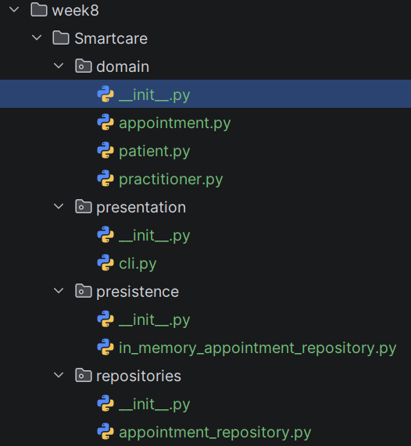


D - Introduce AppointmentService
Move workflow coordination into a focused service without stealing Appointment domain behaviour.
Find in smartcare in week 8

E - Repository Abstraction
Define a small AppointmentRepository contract using only current use-case needs.
Find in smartcare in week 8

F - AI Architecture Review
Ask AI to review dependency direction, misplaced responsibilities and unnecessary complexity; request simplest justified improvements.

G - Refactor and Verify
Apply only justified changes and confirm required behaviour remains unchanged.
=== SmartCare Demo ===
Enter patient name: 1
Enter patient id: 1
Enter practitioner's name: 1
Enter practitioner's id: 1
Enter practitioner's specialty: 1
book, view, cancel or quit?book
Enter appointment time (e.g., 2024-07-20 10:00 AM): 1
Appointment booked successfully!
Status: Booked
book, view, cancel or quit?view
Your appointments:
1. 1 with 1
book, view, cancel or quit?cancel
Your appointments:
1. 1 with 1
Select appointment to cancel: 1
Appointment cancelled.
Status: Cancelled
book, view, cancel or quit?book
Enter appointment time (e.g., 2024-07-20 10:00 AM): 1
Appointment booked successfully!
Status: Booked
book, view, cancel or quit?book
Enter appointment time (e.g., 2024-07-20 10:00 AM): 1
Failed to book appointment: Practitioner is busy at 1
book, view, cancel or quit?book
Enter appointment time (e.g., 2024-07-20 10:00 AM): 2
Appointment booked successfully!
Status: Booked
book, view, cancel or quit?book
Enter appointment time (e.g., 2024-07-20 10:00 AM): 3
Appointment booked successfully!
Status: Booked
book, view, cancel or quit?cancel
Your appointments:
1. 1 with 1
2. 2 with 1
3. 3 with 1
Select appointment to cancel: 3
Appointment cancelled.
Status: Cancelled
book, view, cancel or quit?quit

Process finished with exit code 0

Everything still works as intended

H - Reflection
Document one AI suggestion accepted, one modified and one rejected/deferred.

Suggestion from Copilot | Accepted/modified/rejected | Why?
Change the repository list and service’s repository to private. | Accepted | It's good practice to set them to private so other code cannot touch it by accident.
Compare IDs instead of is. | Modified | I changed the order so a missing practitioner is still caught by the domain.
Add InvalidStatusTransitionError | Rejected | It is not required as it does nothing in the current code except make it more complex.

Suggested AI prompt
Act as a software architecture reviewer. Review this small SmartCare Python system against separation of concerns, cohesion, coupling and introductory SOLID principles. Identify concrete layer violations and dependency risks. Prefer the simplest refactoring that solves an observed problem. Do not introduce frameworks, microservices or patterns unless current requirements justify them.

